

Client Logs System Requirements

Version 1.0

August, 2018

Table of Contents

1 Executive Summary 3

1.1 Project Overview 3

2 Product Description 3

2.1 Overview 3

3 Data Flow Diagram 4

Requirements 5

3.1 Home Page 5

3.2 Search Contract Renewals 5

3.3 Enter / Modify Contract Renewal Information 5

3.4 Maintain Contract Renewal Types 5

3.5 Maintain Contract Renewal Statuses 5

3.6 Maintain Contract Renewal Email Address List 5

4 User Roles 6

Use Cases 7

5 Screen Mock-Ups 8

6 Stakeholder Sign-Off 12

# Executive Summary

## Project Overview

Create a web-based application for entering Contract Renewal forms.

# Product Description

Create an add-on screen to PI Contracts where Contract Renewal information can be entered. All the data contained on the current form will be entered in a web page and stored in the PI database so that reporting can be developed.

The Contract Renewal form can be initiated by Contacts, and routed to the pricing team for the pricing information to be entered, then routed back to contracts when the pricing is complete. Routing is done by assigning a current user and sending an email notification to that user. When the form is complete, the Contract team can export the contract to a PDF file and continue with the current procedure of DocuSign routing for approvals.

# Data Flow Diagram

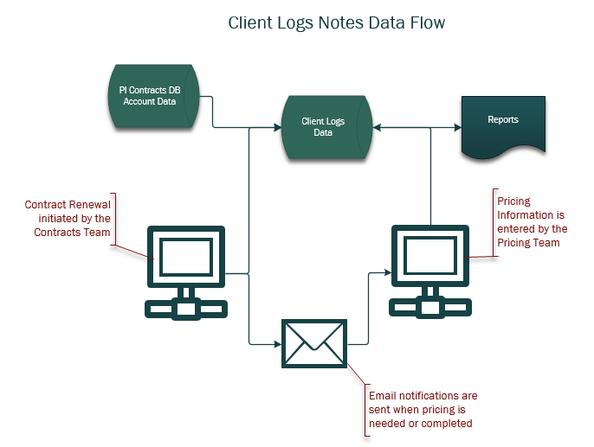

# Requirements

* Dashboard
* Search Contract Renewals
* Enter / Modify Contract Renewal
* Maintain Contact Renewal Types
* Maintain Contact Renewal Statuses
* Maintain Contact Renewal Email Addresses

## Dashboard

The dashboard will show those contracts assigned to the user along with the current status of the contract.

## Search Contract Renewals

The search page is where you can do a lookup of any contract renewal form. You can view, print or edit a contract renewal form or enter a new contract renewal. You can also save a Contract Renewal form as a PDF or Word Document.

## Enter / Modify Contract Renewal Information

A pop-up screen will allow entry of all information currently contained in the contract renewal form. The contract ream will initiate new contracts, enter the dates and other basic information. When the contract is ready for pricing, the contract team will be able to assign the form to the user who will enter the pricing (ex. Paul or John D.) and send an automated email notification to the user. A Notes section will allow free form entry of information to be shared about the contract.

## Maintain Contract Renewal Types

Users with the Contract role will maintain the list of Contract Renewal Types (ex. Renewal, Upsell, Modification).

## Maintain Contract Renewal Statuses

Users with the Contract role will maintain the list of Contract Renewal Status values that will assist in keeping track of where a contract is within the renewal process.

## Maintain Contract Renewal Email Address List

Users with the Contract role will be enter and maintain the list of users who will receive email notifications when a contract status changes.

# User Roles

* Contract – Users with the Contract user role will enter and edit Contract Renewals and maintain the definition tables.
* Pricing – Users with the Pricing user role will enter pricing information in the Contract Renewal form.

# Use Cases

* Initiate a Contract Renewal – Contract user role
* Enter Pricing Information for a Contract Renewal – Pricing user role
* Enter Notes – all user roles. Users cannot modify a note that was entered by another user.
* Enter and Maintain Contract Renewal Types – Contract user role
* Enter and Maintain Contract Renewal Status – Contract user role
* Enter and Maintain Contract Renewal Email Addresses – Contract user role
* View or print or save a Contract Renewal Form as a PDF – all user roles

# Screen Mock-Ups

# Search

* View list of existing Contracts with search and export capabilities.
* Edit existing contract to fix errors, or add new contract with new dates.
* Can print or save as PDF or Word Document.

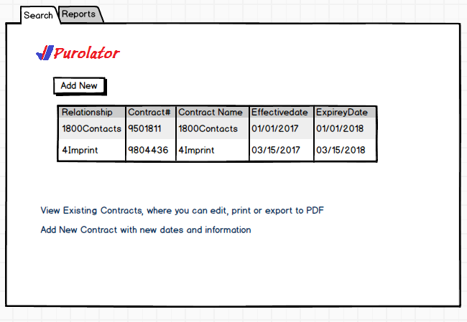

**Enter New Contract Renewal**

* Select relationship from the list of relationships in the system.
* Select Contract # from the list of contracts for the selected relationships.
* Multiple contract numbers can be entered.

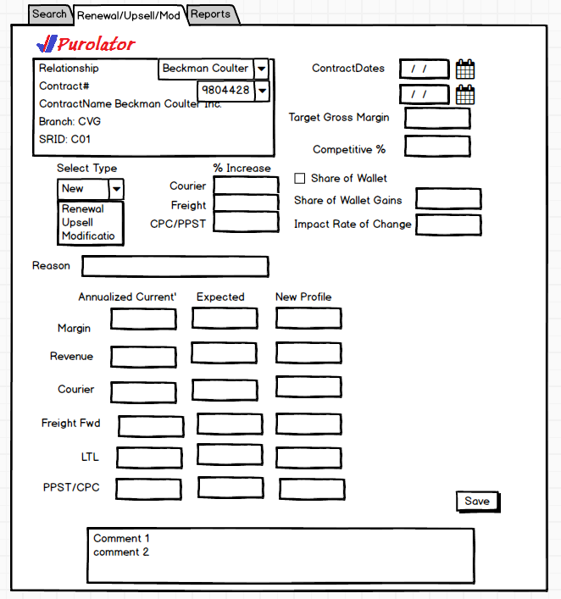

# Stakeholder Sign-Off

Include documentation of the approval or confirmation of the requirements here. For example:

|  |  |  |
| --- | --- | --- |
| Meeting Date | Attendees (name and role) | Comments |
|  |  |  |
|  |  |  |